# e3Learning - Programming Test

The project was developed using STS (Spring Tool Suite) which is a flavor of the eclipse IDE, so configuration here applies to eclipse IDE too, but it will be required to download the maven plugin for eclipse separately as it is not shipped with eclipse but shipped with STS.

* In order to import the project into STS or eclipse , it should be imported as a maven project :

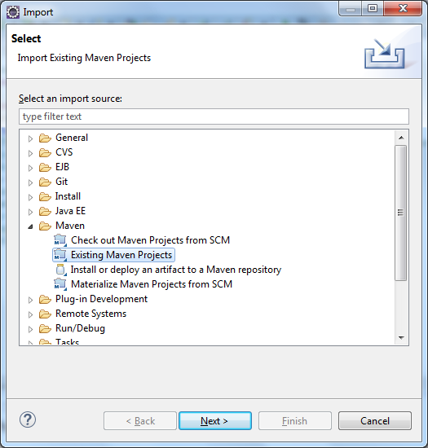

* The project is located under this path in github repository: /Project/interview-task so browse and import it

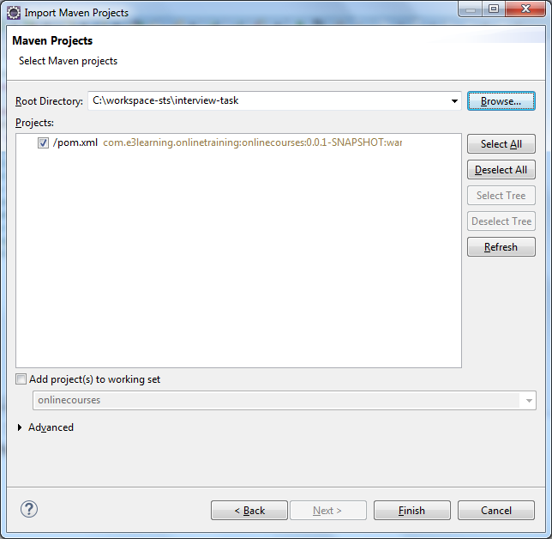

* It will take eclipse some time to download dependencies and configure the project, but once done, the project should show no errors as below

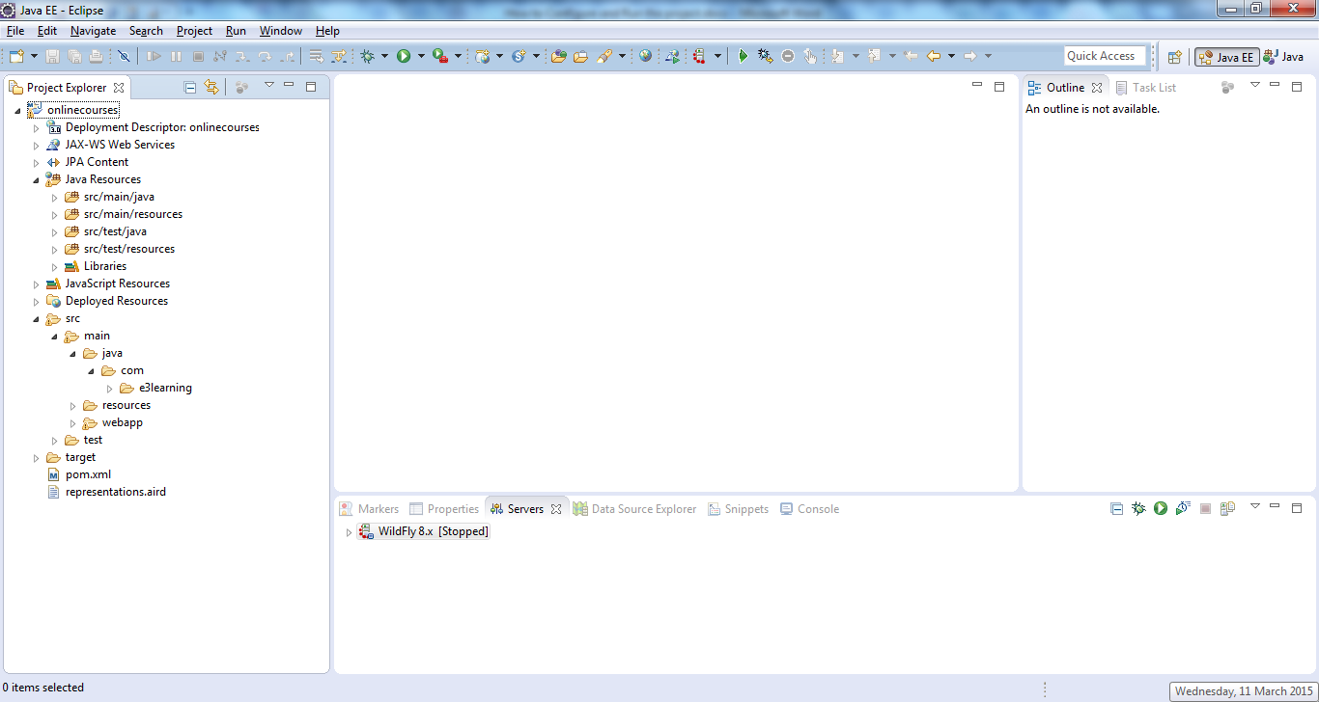

* You can either run the project from eclipse if you have application server plugins installed on eclipse, or you can use the war file in the configuration folder to deploy it separately to an application server, or you can run maven install command to build the war and then deploy it manually to the server.
* Before being able to run the project the below configuration should be done:

- As per requirements MySQL was used as the database for the project, so in order to run the project there must be an installed version of MySQL with the required tables, the scripts for creating the schema and populating the countries table are included in the following path under github repository:

/Artifacts/DB

so you should run "schema creation script.sql" file first then "dumping data for countries table.sql" to populate the countries table. Once done database should be ready.

- The project uses Spring Data JPA library, the application context file is under *src/main/resources* and called *jpaContext.xml* , the file contains the information needed to connect to the database, you can connect to the database using either a JNDI data source or the Spring Driver Manager Data Source, I have included a sample configuration for how to configure the JNDI data source for mysql on wildfly 8.1 if you want to test the application using a JNDI data source then use the sample configuration to configure it then uncomment the related section in the jpaContext.xml file.

If you are going to use Spring Driver Manager Data Source, then you just need to fill in the connection information in the required section in jpaContext.xml by providing the url, username and password to connect to the database.

I tested the project on wildfly 8.1 using JNDI datasource and on Pivotal tc server v3.0 using Spring Driver Manager Data Source, so both cases should be fine, just make sure you uncomment the required section in the jpaContext.xml and fill it with the correct data.